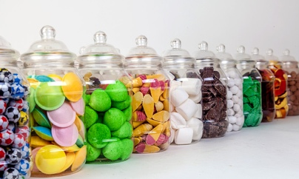

Christmas Fair Jarbola

Following the great success of our Jarbola last year Mrs Hurwood and Mrs Fairbank’s Year One class are organising a Jarbola again for the Christmas Fair along with hosting a class competition.

The challenge is to see how many jars each class can fill ready for our exciting ‘Jarbola’. Just get an empty glass jar, wash it out, remove any labels and fill it with any treats you wish.

Here area few ideas - sweets, make up, craft things, stationery (pencil, rubbers, pens etc. or a small soft toy.
Can you think of anymore?

Please bring the jars into school by Monday 19th November. Year One will collect the jars and award the winning class with a special prize.

These jars of delights will then be sold at our Jarbola.

