23rd November 2017

Year 1 Parents

Dear Parents

I write to inform you that as from tomorrow Mrs Katie Hannah will begin teaching in Year 1 alongside Mrs Stillings, replacing Miss Routledge. Mrs Hannah will be teaching in Year 1 on Thursday/Friday and teaching in EYFS on Monday/Tuesday and Wednesday afternoon.

I do appreciate that a further change of teaching personnel mid-year may be unsettling, however as Mrs Hannah taught in EYFS last year she knows all the children really well so I envisage this change to be very positive and highly beneficial.

If you have any queries about this new arrangement please do not hesitate to contact myself or Mrs Stillings.

Yours sincerely

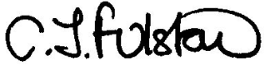

Mrs C. Fulstow
Headteacher

