9th October 2018
Dear Parents,
As many of you are aware, we have been trialling the use of ClassDojo. Teachers can reward children with house points which relate to our Moral Compass values. The app also has a messaging feature which enables direct communication between teachers and parents for enquiries, reminders and ideas to support your child. Please continue to use Tapestry to send learning from home.
We would now like to introduce ClassDojo to EYFS as a way of further strengthening our home school links. ClassDojo app is free to download in the Apple App Store and Google Play. To connect with your child, simply download the ClassDojo app and type in the code provided on your child’s registration letter.
The app enables us to create a home-school dialogue where children can discuss their house point achievements. Teachers will review messages regularly. You will be able to see your child’s house points by simply click on ‘Kids’ tab, select the child and select ‘View Name’s report’.

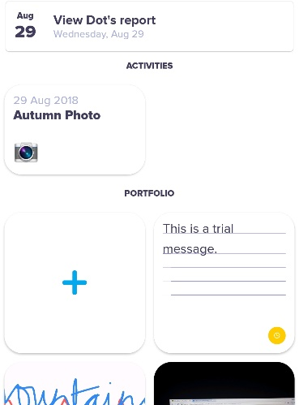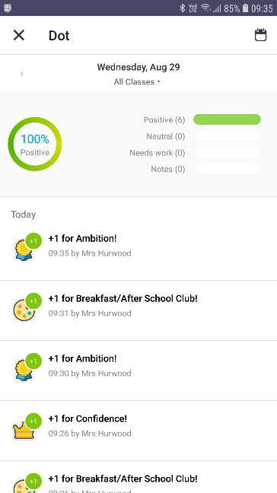

We really believe this is an excellent way to give you an insight into your child’s achievements at school. If you have any questions, I will be available on the playground after school on Tuesday 16th October.

Yours sincerely,

Mrs Hurwood
Computing Coordinator

