27th September 2018
Dear Parents,
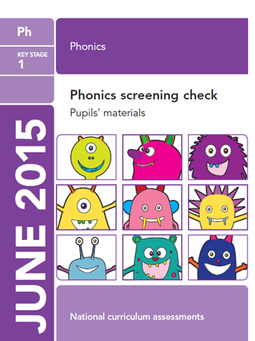
We will be holding a ‘Phonics Information’ session on Monday 15th October at 3:40pm in the hall. All Year 1 children will participate in the National Phonics screening check in May 2019. The information session will provide details of the screening check, the ways in which we will prepare the children and ways you can support your child at home.
Please complete and return the slip below by Monday 8th October.
Many thanks,
The Year 1 Team

Child’s name:_______________________________

I/we will be attending the information session.

I/we will not be attending the information session.

Parents Signature……………………………………………………………

