23rd November 2018
Dear Parents,
We are very proud of our Early Years at Elloughton Primary school and what we have been able to achieve with our limited budget and support from FESA, we never stop trying to seek new and innovative ideas to progress children’s learning and experience of school!
Our next vision is to extend the sand area, allowing the children to have the space to develop their gross motor skills and spatial awareness. When it comes to sand we believe the bigger the better! Furthermore, the addition of water, through the installation of a large pump, means that children can strengthen their arm and hand muscles and experiment with the effect water has on sand.
We would like to build an outdoor platform which will give them the opportunity to realistically mimic the working world of adults along with a pulley system which involves children working together encouraging cooperation and communication.
We have already had some parents and contacts come forward to help us achieve this vision in the form of reduced labour costs but we still need to buy the equipment and materials. The school is applying for a grant from Tesco, however this will only go so far to achieving this vision.
So, we are seeking the generosity of parents in Early Years and Nursery to help by sponsoring the project to help our children learn and develop in what will be a fun and innovative way, unique to Elloughton Primary School. If you, or a company you know of would be willing to donate and sponsor this exciting project for the children the money raised will provide a water pump, sand platform and pulley system to enhance our outdoor environment.
All company donations will be recognised on a plaque in the outdoor area of the project and of course in our whole school newsletter giving sponsors positive recognition. Donations can be made to the school either via a BACs payment to our School Fund account: sort code 40-42-25 account number: 31081519, or alternatively a cheque made payable to Elloughton Primary School.
Thank you for helping to create something magical!
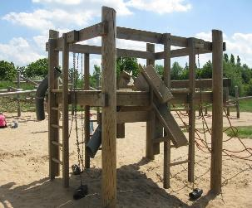
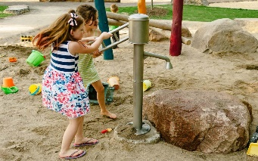
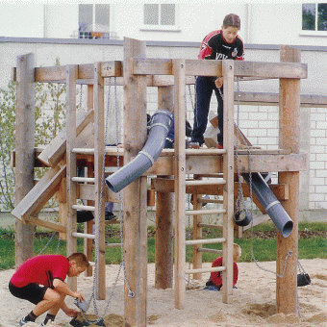
The EYFS Team

