Our First Official Panini Swapsie
Football Club!!

Thursday Lunchtime’s at 12.30pm
in Mrs Stillings Classroom

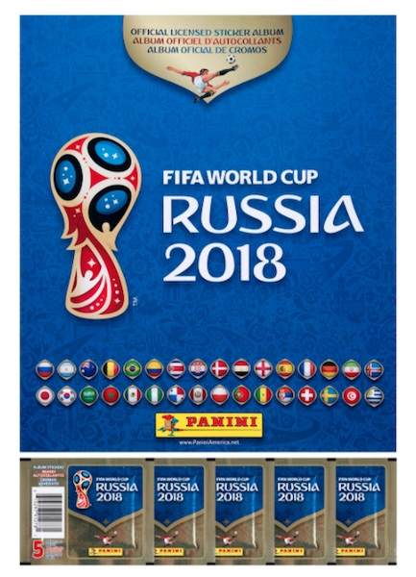

Please bring your Panini FIFA World Cup 2018 album and your ‘double’ stickers to swap with others.

