5th October 2018
Dear Parents,
As many of you are aware, we have been trialling the use of Seesaw, a digital learning journey like Tapestry and 2BuildaProfile, and feedback has been very positive. Here are some comments from parents involved with our trial.
“We’re really enjoying seeing what [our child] gets up to at school. It’s lovely to see how confident he is in front of the camera and how well he works with others.”
“I’m loving seeing the work [our child] posts. Really impressed with the app. Thank you.”
“I think the app is brilliant and we have all enjoyed looking at [our child’s] work very much.”
“[Our child] is always so excited to come home and tell me she has uploaded something. We have really enjoyed sharing what [our child] does at school as this is something we missed seeing from Reception.”
Following the success of this trial, we have found a further app, ClassDojo, which looks to be even more successful. In their daily classroom routine, the children independently take photographs or videos to showcase their learning using iPads or tablets.
They are taught to add text, drawings or voice recordings to explain what they have done which is then added to their learning portfolio. Teachers can comment positively on the work or provide ways forward to further the learning. All uploads are sent for teacher approval before being added to their learning portfolio.
Teachers can also upload items to a ‘Class Story’ which connected parents in the class can see. This gives teachers a quick way to share celebrations, class events, proud moments and reminders. The app also has a messaging feature which enables direct communication between teachers and parents for enquiries, reminders and ideas to support your child.
We would now like to introduce ClassDojo to Years 1-4 as a way of further strengthening our home-school links. ClassDojo app is free to download in the Apple App Store and Google Play. To connect with your child, simply download the ClassDojo app and type in the code provided on your child’s registration letter. Your child can also upload content from home using the app. When logged in as a parent, simply select the ‘Kids’ tab at the bottom, click on your child’s name and select ‘Setup Name’s Account’.
The app is to create a home-school dialogue where children can discuss their learning at home, share their proud moments and then parents can leave comments. Teachers will review uploaded content and messages regularly. In addition to portfolios, you will be able to see your child’s house points. Simply click on ‘Kids’ tab, select the child and select ‘View Name’s report’.
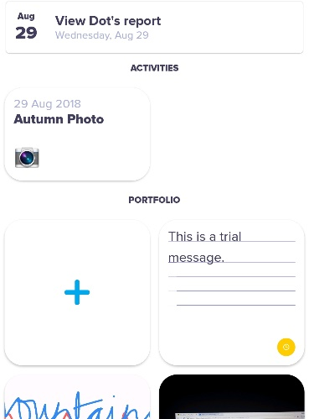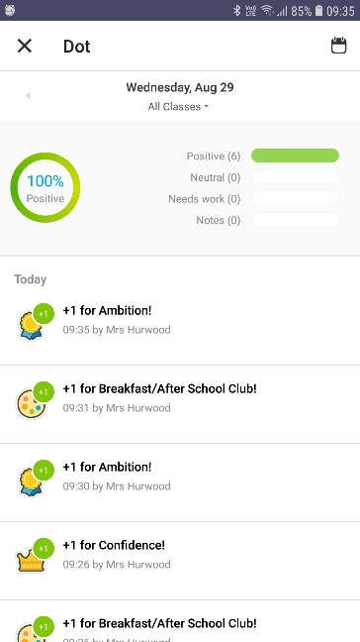

We really believe this is an excellent way to give you an insight into your child’s achievements at school. If you have any questions, I will be available on the playground after school on Tuesday 9th October.
Yours sincerely,
Mrs Hurwood
Computing Coordinator

